**1. Create a list that displays the title of each book and the name and phone number of the contact at the publisher’s office for reordering each book.**

a.

SELECT title, contact, phone

FROM books b, publisher p

WHERE b.pubid = p.pubid;

b.

SELECT title, contact, phone

FROM books b JOIN publisher p

ON b.pubid = p.pubid;

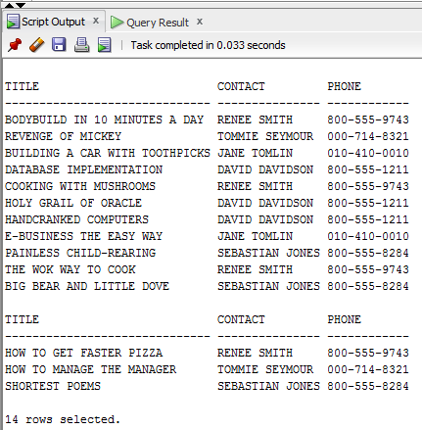

**2. Determine which orders haven’t yet shipped and the name of the customer who placed the order. Sort the results by the date on which the order was placed.**

a.

SELECT order#, (firstname ||' '|| lastname) name

FROM orders o, customers c

WHERE o.customer# = c.customer#

AND o.shipdate IS NULL;

/*ORDER by ??????*/

b.

SELECT order#, (firstname ||' '|| lastname) name

FROM orders o JOIN customers c

ON o.customer# = c.customer#

AND o.shipdate IS NULL;

/*ORDER by ??????*/

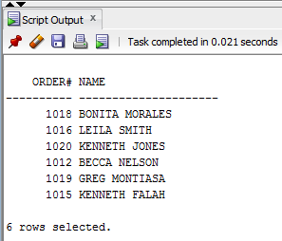

**3. Produce a list of all customers who live in the state of Florida and have ordered books about computers.**

a.

SELECT c.customer#, c.firstname ||' '|| c.lastname name, o.order#, i.ISBN, b.category, c.state

FROM customers c, orders o, books b, orderitems I

WHERE c.customer# = o.customer#

AND o.order# = i.order#

AND oi.isbn = b.isbn

AND STATE = 'FL'

AND b.category = 'COMPUTER';

b.

SELECT customer#, c.firstname||' '||c.lastname name, order#, ISBN, b.category, c.state

FROM customers c JOIN orders o USING (customer#)

JOIN orderitems i USING (order#)

JOIN books b USING (ISBN)

WHERE state = 'FL' AND category = 'COMPUTER';

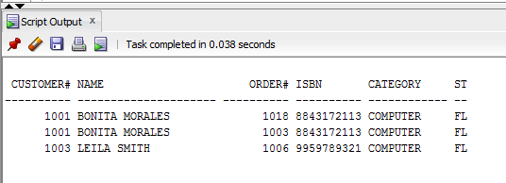

**4. Determine which books customer Jake Lucas has purchased. Perform the search using the customer name, not the customer number. If he has purchased multiple copies of the same book, unduplicate the results.**

a.

SELECT DISTINCT b.title

FROM customers c, orders o, orderitems i, books b

WHERE c.customer# = o.customer#

AND o.order# = i.order#

AND i.isbn = b.isbn

AND c.firstname = 'JAKE'

AND c.lastname = 'LUCAS';

b.

SELECT DISTINCT b.title

FROM customers c JOIN orders USING (customer#)

JOIN orderitems USING (order#)

JOIN books b USING (isbn)

WHERE c.firstname = 'JAKE'

AND c.lastname = 'LUCAS';

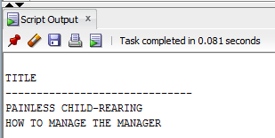

**5. Determine the profit of each book sold to Jake Lucas, using the actual price the customer paid (not the book’s regular retail price). Sort the results by order date. If more than one book was ordered, sort the results by profit amount in descending order. Perform the search using the customer name, not the customer number.**

a.

SELECT orders.orderdate, books.title, (orderitems.paideach-books.cost) "PROFIT"

FROM customers, orders, orderitems, books

WHERE customers.firstname = 'JAKE'

AND customers.lastname = 'LUCAS'

AND customers.customer# = orders.customer#

AND orderitems.order# = orders.order#

AND books.ISBN = orderitems.ISBN

ORDER BY profit DESC, orderdate;

b.

SELECT orders.orderdate, books.title, (orderitems.paideach-books.cost) "PROFIT"

FROM CUSTOMERS NATURAL JOIN orders

NATURAL JOIN orderitems

NATURAL JOIN books

WHERE customers.firstname = 'JAKE'

AND customers.lastname = 'LUCAS'

ORDER BY profit DESC, orderdate

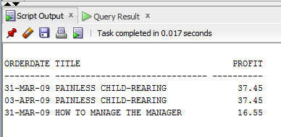

**6. Which books were written by an author with the last name Adams? Perform the search using the author name.**

a.

SELECT books.title

FROM books, bookauthor, author

WHERE books.ISBN = bookauthor.ISBN

AND bookauthor.authorid = author.authorid

AND author.lname = 'ADAMS';

b.

SELECT books.title

FROM books

NATURAL JOIN bookauthor

NATURAL JOIN author

WHERE author.lname = 'ADAMS';



**7. What gift will a customer who orders the book Shortest Poems receive? Use the actual book retail value to determine the gift.**

SELECT books.title ,books.retail "RETAIL COST",orders.shipcost,orderitems.paideach,(books.retail+orders.shipcost-orderitems.paideach) AS "CUSTOMER GIFT"

FROM books,orderitems,orders

WHERE title='SHORTEST POEMS'

AND books.ISBN=orderitems.ISBN

AND orderitems.ORDER#=orders.ORDER#

**8. --please read the text**

**Identify the authors of the books Becca Nelson ordered. Perform the search using the customer name.**

SELECT author.lname||','||author.fname "AUTHOR"

FROM customers, orders, books, orderitems, bookauthor, author

WHERE customers.customer# = orders.customer#

AND orders.order# = orderitems.order#

AND orderitems.isbn = books.isbn

AND books.ISBN = bookauthor.ISBN

AND bookauthor.authorid = author.authorid

AND customers.lastname = 'NELSON'

AND customers.firstname = 'BECCA';

SELECT author.lname||','||author.fname "AUTHOR"

FROM customers

NATURAL JOIN orders

NATURAL JOIN books

NATURAL JOIN orderitems

NATURAL JOIN bookauthor

NATURAL JOIN author

WHERE customers.lastname = 'NELSON'

AND customers.firstname = 'BECCA';

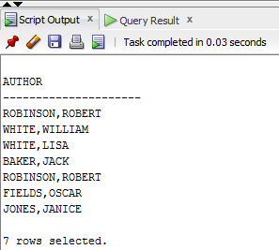

**9. --please read the text**

**Display a list of *all* books in the BOOKS table. If a book has been ordered by a customer, also list the corresponding order number and the state in which the customer resides.**

SELECT books.title, orders.order#, orders.shipstate

FROM books, orderitems, orders

WHERE orderitems.order# = orders.order#(+)

AND books.isbn = orderitems.isbn(+);

SELECT books.title, orders.order#, orders.shipstate

FROM books LEFT JOIN orderitems

ON books.isbn = orderitems.isbn

LEFT JOIN orders

ON orderitems.order# = orders.order#;

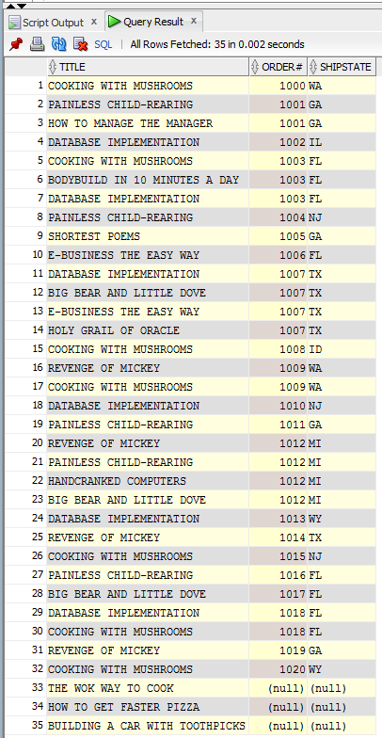

**10. --please read the text**

**An EMPLOYEES table was added to the JustLee Books database to track employee information. Display a list of each employee’s name, job title, and manager’s name. Use employees in the list and sort by manager name.**

SELECT e.fname || ' ' || e.lname "Employee Name", e.job,em.fname || ' ' || em.lname "Manager Name"

FROM employees e, employees em

WHERE e.mgr = em.empno (+)

ORDER BY "Manager Name";

SELECT e.fname || ' ' || e.lname "Employee Name", e.job,em.fname || ' ' || em.lname "Manager Name"

FROM employees e LEFT OUTER JOIN employees em

ON e.mgr = em.empno

ORDER BY "Manager Name";

